Kepang AI
Decision Intelligence untuk Resiliensi Ketahanan Pangan Daerah
Combined Submission Attachment - Tahap 2
Purpose
One PDF package for judges: problem evidence, solution fit, architecture, data policy, impact KPI, business model, MVP readiness, and validation gaps.

Field | Content
Team ID | [ISI ID TIM SESUAI PENDAFTARAN]
Team Name | J4
Proposal Title | Kepang AI: Decision Intelligence untuk Resiliensi Ketahanan Pangan Daerah
Prototype Status | Local web prototype with backend API, Supabase database, source-aware forecasting, logistics recommendation, and Evidence Room
File Naming Rule | Rename final file to: [ID Team] - Kepang AI Decision Intelligence untuk Resiliensi Ketahanan Pangan Daerah.pdf

1. Executive Evidence Summary
Kepang AI is a decision intelligence prototype for food resilience. The core problem is policy lag: price, weather, stock, logistics, and macro pressure are often analyzed separately, so intervention can arrive after food prices have already moved.
The solution connects official data, real-time-capable feeds, model-derived forecasts, and explicit data gaps into one decision cockpit. The app turns signals into Resilience Score, scenario shock, route recommendation, action cards, KPI targets, and data lineage.
Evidence Signal | Why It Matters | Kepang AI Response
Volatile food 6.24% yoy | Food commodities remain a current inflation pressure | Food Inflation Monitor and commodity risk
USD/IDR Rp17,700 | Weaker rupiah raises imported inflation and logistics exposure | Rupiah scenario planning and import exposure
Weather risk | Flood, drought, and climate shocks affect production | BMKG-based Weather Risk Engine
Regional imbalance | Surplus and deficit regions need coordinated distribution | Supply-demand map and route recommendation
Data trust gap | Forecast, seed, and official data must not be mixed | Data lineage labels and expected data fields

2. Evidence of Demand
Demand is demonstrated by public problem evidence and institutional need. Stakeholders do not only need another dashboard; they need a shared decision layer that explains what happened, why it matters, what action should be prioritized, and which data can be trusted.
Real Problem Evidence | Source | Demand Signal
Inflasi Mei 2026 mencapai 3.08% yoy dan 0.28% mtm | BPS, 2 June 2026 | Price stability is an active public issue
Volatile food mencapai 6.24% yoy | Antara citing BPS | Strategic food commodities still drive inflation pressure
Rupiah Rp17,700/USD and BI-Rate 5.25% | Bank Indonesia RDG May 2026 | Macro shock requires resilient scenario planning
Imports Jan-Feb 2026 reached US$42.09B, +14.44% yoy | BPS export-import release | Imported inputs, energy, and logistics can become more expensive
Bapanas mission includes reserve, logistics, distribution, stabilization, and vulnerable regions | Bapanas Renstra 2025-2029 | The solution aligns with institutional mandate
BMKG provides 3-day village-level weather forecast, updated twice daily | BMKG Open Data | Weather data can feed early warning for food risk

3. Problem-Solution Mapping
Problem | Mechanism | Outcome
Fragmented food data | Integrate price, supply-demand, weather, macro, and logistics in one cockpit | Decision makers see root causes, not only price symptoms
Policy lag | Early warning, Resilience Score, action cards, redistribution recommendation | Stock intervention, market operation, and harvest mitigation can start earlier
Weaker rupiah and imported inflation | Currency scenario planning, import exposure, logistics-cost simulation | Food decisions become more resilient against external shocks
Unclear data quality | Data lineage: real-time, official-release, forecast, unavailable | Every recommendation is more auditable and honest
Suboptimal logistics route | Route ranking, volume estimate, optional Google ETA/distance, expected partner data | Distribution from surplus to deficit regions becomes more targeted

4. System Architecture
The architecture separates user interface, API orchestration, data storage, external data connectors, model outputs, and data lineage. This supports a transparent MVP today and a production path with institutional data partners later.
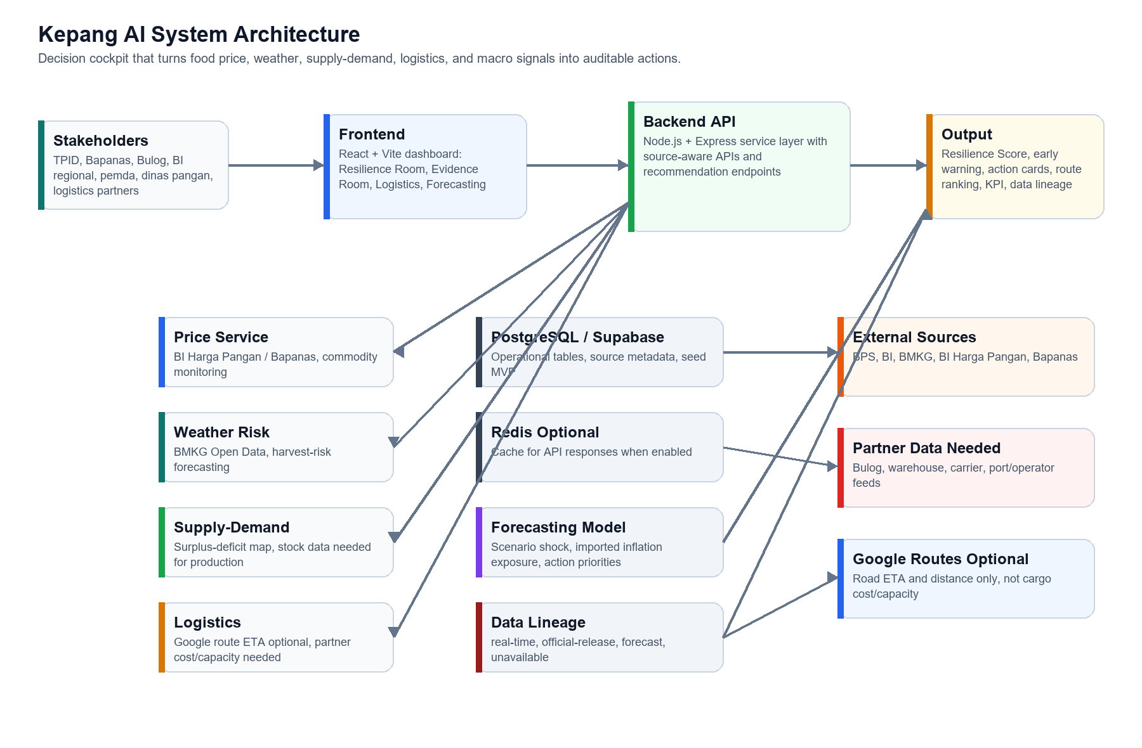

5. Data Source and Feasibility Matrix
Dataset | Current Status | Source / Method | Production Requirement
Inflation and macro | official-release | BPS and BI releases | Periodic official update ingestion
Weather forecast | real-time capable | BMKG Open Data | adm4 mapping for all target regions
Food prices | real-time capable | BI Harga Pangan scraper/API; Bapanas when stable | Stable endpoint access and source logging
Supply-demand | forecast / seed MVP | Prototype seed; expected Bapanas/Bulog/Dinas data | production_ton, stock_ton, demand_ton, warehouse_id
Logistics ETA/distance | real-time capable when key exists | Google Routes API for eligible road routes | Google key and road-routable origin/destination
Logistics cost/capacity | forecast / unavailable | Prototype route table | carrier, capacity_ton, cost_per_ton, lead_time_days
Resilience score | forecast | Kepang AI model | Validation against historical interventions

Data honesty rule
Kepang AI must not present seed, proxy, or model output as audited real-time data. Every displayed dataset is labelled as real-time, official-release, forecast, or unavailable.

6. Impact Measurement
KPI | MVP Target | Measurement Method
Time to identify priority region | Under 3 minutes | User task test with TPID/dinas pangan persona
Time-to-insight reduction | 50% vs manual baseline | Compare dashboard task vs spreadsheet/manual workflow
Simulated supply gap reduction | At least 30% | Before-after redistribution scenario
Logistics cost potential | 5-10% | Cost per ton before-after route optimization
Data lineage completeness | 100% | Audit UI and API response
Recommendation validation | 5-10 interviews | Structured interview scorecard

7. Business Model and Sustainability
Revenue Stream | Buyer | Value Sold
Annual institutional license | Pemda, TPID, Bapanas, Bulog, BI regional | Dashboard, user seats, modules, regional coverage
Implementation fee | Pilot institution | Setup, data integration, training, custom workflow
Managed analytics | Government or enterprise partner | Monthly risk report and scenario briefing
API subscription | Institutions, logistics, finance, insurance | Risk score, anomaly signal, route intelligence
Logistics add-on | Carrier, warehouse, commodity aggregator | Route optimization, backhaul, capacity matching
Grant / innovation funding | Public program, CSR, donor | Early pilot, validation, and social impact deployment

The product monetizes the intelligence layer, not raw public data. Profitability can come from recurring institutional subscriptions, implementation services, managed analytics, and API/logistics add-ons once pilots prove measurable value.

8. Guidebook Alignment
Guidebook Criterion | Evidence in Kepang AI | Status
Alignment with Problem Statement | Digitalisasi Ketahanan Pangan, policy lag, supply-demand, price, weather, logistics, and rupiah | Ready
Effectiveness & Impact | Resilience Score, action cards, KPI targets, supply gap, route efficiency | Ready for MVP
Uniqueness / Creativity | Decision cockpit, rupiah shock scenario, data lineage, source-aware logistics | Ready
Technical Quality | React/Vite, Express, PostgreSQL/Supabase, BI scraper, BMKG service, Google optional | Prototype ready
Business Model Feasibility | B2G SaaS, implementation fee, managed analytics, API subscription, logistics add-on | Ready

9. MVP Readiness and Test Evidence
Check | Result | Observation
Frontend build | Pass | Vite production build completed; chunk-size warning non-blocking
Backend syntax checks | Pass | forecast route, logistics route, googleRoutesService valid
GET /api/health | Pass | status=ok, database=ok, redis=disabled locally
GET /api/forecast/resilience | Pass | Macro context, resilience score, data policy, data provenance returned
GET /api/logistics/recommendations | Pass | Ranked routes, source policy, expected production data returned
Browser checks | Pass | Evidence Room and Dashboard render with no mojibake

10. Open Gaps and Next Validation
- Fill final Team ID and confirm official team composition before submission.
- Run 5-10 structured interviews with TPID, dinas pangan, Bulog/logistics, BI regional, commodity traders, and warehouse/carrier operators.
- Integrate production stock, warehouse, carrier capacity, port congestion, and actual cost-per-ton feeds when partner access is available.
- Configure Google Maps keys only for road ETA/distance; do not claim sea/cargo cost or capacity as Google real-time data.
- Prepare a 2-3 minute demo video as backup if public hosting is deferred.

11. Source Links
Source | URL
BPS Inflasi Mei 2026 | https://www.bps.go.id/id/pressrelease/2026/06/02/2579/inflasi-year-on-year--y-on-y--pada-mei-2026-sebesar-3-08-persen-.html
Antara/BPS volatile food | https://www.antaranews.com/berita/5590715/bps-kenaikan-bbm-nonsubsidi-dorong-inflasi-transportasi-061-persen
BI RDG Mei 2026 | https://www.bi.go.id/id/publikasi/ruang-media/news-release/Pages/sp_2810726.aspx
BPS Ekspor-Impor Februari 2026 | https://www.bps.go.id/assets/pressrelease/2026/04/01/2557/ekspor-dan-impor-indonesia-februari-2026-masing-masing-tercatat-usd-22-17-miliar-dan-usd-20-89-miliar-.html
BPS NTP Mei 2026 | https://www.bps.go.id/id/pressrelease/2026/06/02/2580/nilai-tukar-petani--ntp--mei-2026-sebesar-127-73-atau-naik-1-99-persen.html
BMKG Open Data | https://data.bmkg.go.id/prakiraan-cuaca
Bapanas Renstra 2025-2029 | https://peraturan.go.id/filespengundangan/peraturan-bapanas-no-9-tahun-2025.pdf

